Next Phase of Your Implant Surgery

Stage 2- Uncovering the implant

What’s next after your implant surgery?

After the implant has bonded to the jawbone, in three months the second phase begins.
Dr. Su will uncover the implant(s) and attach a small post that protrudes through the gum and will act as an anchor for the artificial tooth (When the artificial tooth is placed by your general dentist, the post will not be seen).

The uncovering of the implant is usually a very minor procedure. The entire process usually takes about 15 min.

What happens during an implant uncovering?

After the doctor has concluded that the implant integration is complete, the dental implant has to be uncovered:
- Local anesthesia is administered.
- A small incision is done in the gum, allowing doctor to unscrew the surgical cover screw from the implant.
- The temporary cover screw is removed and the abutment screw is then placed, which projects above the gum preventing the gum from closing over the implant.
- Sutures may be placed to hold the gum back in place depending on the incision made.

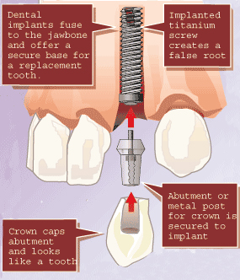

*You are welcome to schedule your uncovering appointment within three months of the implant surgery or we can put you on our call back list.

